To Decrease Voice for Videos of Whatsapp/Youtube decrease vol in corresponding Apps not System Tray

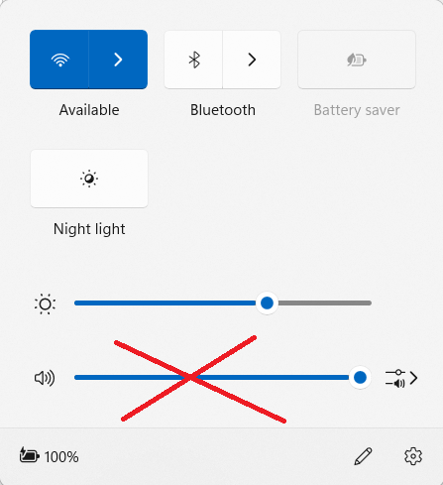

Clear Search History from Settings at Botton Right corner

On Weekends read Kids TOI and Whatsapp of 2 members

Never delete items Sent by myself to me having Imp Mails label

In GPay to check item rates use Transaction History-Search

Use “Pack of 4” while ordering Soaps

IFSC Code-11 Digits

Acc num-After 220, 3 zeros

To Book Auto in place where location is not available go to Google maps, search nearby place and then select place the required place in maps. Click Share and then copy location url

Backoffice in LKP shows all the details related to Shares

Read Times Techies on Thursday

Use Print Mode for Images with text to see it in Big font